SIMATS ENGINEERING
Department of Computer Science & Engineering

ASSESSMENT TOOL 1- EXPERIMENTS

Course Code: | CSA1208 | Course Title: | Computer Architecture
CO Assessed: | CO3 | Assessment: | ASSESSMENT TOOL 1-  EXPERIMENTS
Weightage: | 40% | Total Marks: | 25
CO3 Statement: | Design processor organization by constructing pipelined datapath structures, identifying hazard types (data, control, structural), and comparing superscalar techniques such as out-of-order execution, speculative execution, and simultaneous multithreading (SMT). (BL6)
Student Name: | V. Devachary | Reg.No.: | 192465041
Department: | CSE(Cyber Security) | Date: | 20-08-2026

ANNEXURE A

- Design and simulate a system that performs register transfer operations along with basic arithmetic and logic operations such as addition, subtraction, AND, and OR. Use multiple registers to demonstrate how data is transferred between them during execution, and analyze the sequence of operations and the role of the ALU in processing data.
- Create a model of a computer system using single-bus and multi-bus organization, and perform data transfer operations between registers, memory, and I/O. Compare the time taken and efficiency of both approaches, and analyze how multiple bus structures improve parallel data transfer and reduce bottlenecks.
- Simulate a 5-stage instruction pipeline (Fetch, Decode, Execute, Memory, Write-back) and execute a set of instructions. Measure the performance in terms of speedup and throughput, and compare it with a non-pipelined system to evaluate the effectiveness of pipelining.
- Develop a pipeline execution scenario where data hazards, control hazards, and structural hazards occur. Observe their impact on instruction execution, and implement techniques such as stalling, data forwarding, and branch prediction to resolve these hazards and improve performance.
- Analyze a processor supporting superscalar execution, including out-of-order and speculative execution, and extend the study to include hyper-threading and simultaneous multithreading (SMT). Evaluate how multiple instructions are executed in parallel and compare the performance improvements in terms of instruction throughput and resource utilization.

Code of Conduct:

I V. Devachary / 192465041 (Name / Reg No) certify that this submission is my original work and that I have adhered to the guidelines specified for this assessment.I understand that any violation of academic integrity rules will result in disciplinary action.

Signature of the student: V. Devachary

MARKS ALLOCATION

 | Understanding of Concepts (20%) | Experimental Design (20%) | Use of Tools  (25%) | Analysis of Results (20%) | Documentation  (15%)
Q1
Q2
Q3
Q4
Q5

RUBRICS FOR CALCULATION:

Criteria | Weightag e | Level 4 – Exemplary | Level 3 – Proficient | Level 2 – Developing | Level 1 – Beginning
Understanding of Concepts | 25 | Demonstrates thorough understanding and effectively integrates multiple  concepts/technologies | Good understanding with proper integration of most concepts | Basic understanding; limited or partial integration | Poor understanding; unable to  integrate concepts
Experimental Design | 30 | Well-planned, systematic implementation with optimal solution | Correct implementation with minor issues | Basic implementation with errors or  inefficiencies | Incorrect or incomplete  implementation
Use of Tools | 20 | Effective and advanced use of tools/technologies with proper configuration | Appropriate use of tools with correct execution | Limited or inconsistent use of tools | Incorrect or minimal use of tools
Analysis of Results | 15 | Insightful analysis with accurate interpretation and  validation of results | Good analysis with reasonable interpretation | Basic analysis with limited  insights | Poor or incorrect analysis of results
Documentation | 10 | Clear, well-structured documentation with diagrams, code, and results | Organized documentation with necessary details | Basic documentation with missing  details | Poor or  incomplete documentation

Register Transfer and ALU Operations
Aim
To design and simulate a system that performs register transfer operations and basic arithmetic and logical operations such as addition, subtraction, AND, and OR, and to analyze the role of the ALU during data processing.
Algorithm
- Start the program.
- Initialize multiple registers with suitable values.
- Transfer data from one register to another.
- Perform addition using the ALU.
- Perform subtraction using the ALU.
- Perform logical AND operation.
- Perform logical OR operation.
- Display the contents of all registers and ALU results.
- Stop.
Code
#include <stdio.h>
int main()
{
int R1 = 20, R2 = 10;
int R3, R4;
printf("Initial Register Values:\n");
printf("R1 = %d\n", R1);
printf("R2 = %d\n", R2);
/* Register Transfer */
R3 = R1;
R4 = R2;
printf("\nAfter Register Transfer:\n");
printf("R3 <- R1 = %d\n", R3);
printf("R4 <- R2 = %d\n", R4);
/* ALU Operations */
printf("\nALU Operations:\n");
printf("Addition = %d\n", R1 + R2);
printf("Subtraction = %d\n", R1 - R2);
printf("AND = %d\n", R1 & R2);
printf("OR = %d\n", R1 | R2);
return 0;
}
Output
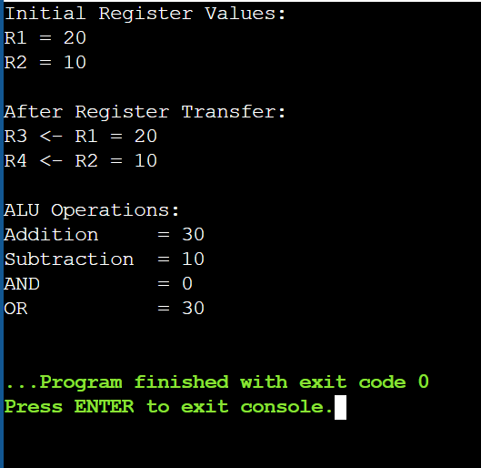
Result
The register transfer and ALU operations were successfully simulated. The experiment demonstrates how data is transferred between registers and how the ALU performs arithmetic and logical operations during instruction execution.

Single-Bus and Multi-Bus Organization
Aim
To simulate data transfer using single-bus and multi-bus organization and compare their efficiency.
Algorithm
- Start.
- Initialize register values.
- Perform data transfers using a single bus.
- Count the required bus cycles.
- Perform transfers using multiple buses.
- Count the required bus cycles.
- Compare both approaches.
- Stop.
C Program
#include <stdio.h>
int main()
{
int R1 = 10, R2 = 20;
int R3, R4;
int singleBusCycles = 0;
int multiBusCycles = 0;
printf("Initial Values:\n");
printf("R1 = %d\n", R1);
printf("R2 = %d\n", R2);
/* Single Bus */
printf("\n--- Single Bus Organization ---\n");
R3 = R1;
singleBusCycles++;
R4 = R2;
singleBusCycles++;
R3 = R3 + R4;
singleBusCycles++;
printf("R3 = R3 + R4 = %d\n", R3);
printf("Single Bus Cycles = %d\n", singleBusCycles);
/* Multi Bus */
printf("\n--- Multi Bus Organization ---\n");
R3 = R1;
R4 = R2;
multiBusCycles++;
R3 = R3 + R4;
multiBusCycles++;
printf("R3 = R3 + R4 = %d\n", R3);
printf("Multi Bus Cycles = %d\n", multiBusCycles);
/* Comparison */
printf("\n--- Comparison ---\n");
if (multiBusCycles < singleBusCycles)
printf("Multi-bus organization is more efficient.\n");
else
printf("Single-bus organization is more efficient.\n");
return 0;
}
Output
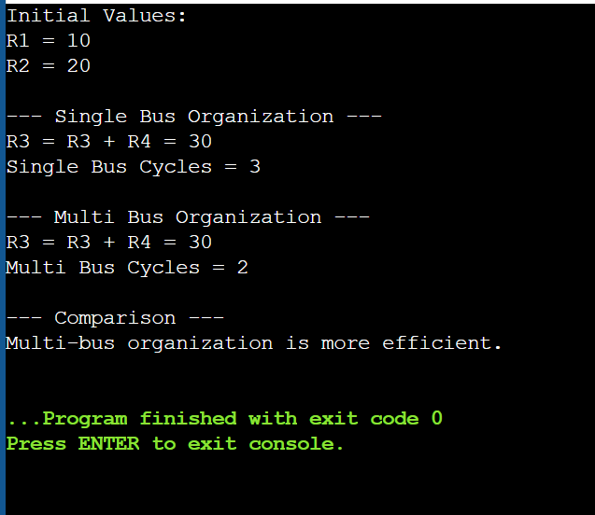
Result
Thus, single-bus and multi-bus data transfer operations were successfully simulated. The multi-bus organization required fewer bus cycles.

Five-Stage Instruction Pipeline
Aim
To simulate a five-stage instruction pipeline consisting of Fetch, Decode, Execute, Memory, and Write-back stages and compare it with a non-pipelined system.
Algorithm
- Start.
- Define the five pipeline stages.
- Enter the number of instructions.
- Calculate pipeline execution cycles.
- Calculate non-pipeline execution cycles.
- Calculate speedup.
- Display the results.
- Stop.
C Program
#include <stdio.h>
int main()
{
int n = 5;
int pipelineCycles;
int nonPipelineCycles;
float speedup;
printf("5-Stage Instruction Pipeline\n\n");
printf("Stages:\n");
printf("1. Fetch\n");
printf("2. Decode\n");
printf("3. Execute\n");
printf("4. Memory\n");
printf("5. Write-Back\n");
/* Pipeline execution */
pipelineCycles = n + 4;
/* Non-pipelined execution */
nonPipelineCycles = n * 5;
speedup = (float)nonPipelineCycles / pipelineCycles;
printf("\nNumber of Instructions = %d\n", n);
printf("Pipeline Cycles = %d\n", pipelineCycles);
printf("Non-Pipeline Cycles = %d\n", nonPipelineCycles);
printf("Speedup = %.2f\n", speedup);
return 0;
}
Output
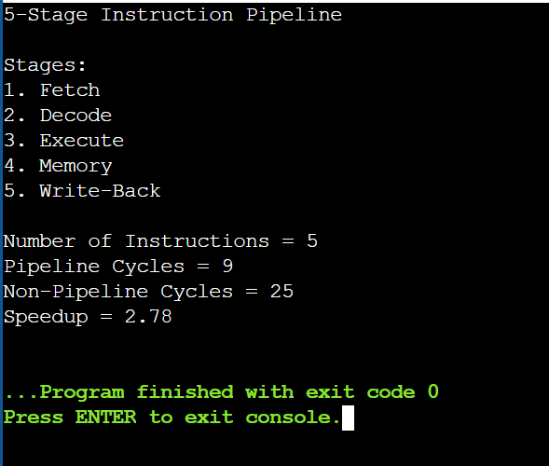
Result
Thus, the five-stage instruction pipeline was successfully simulated. The pipelined system required fewer cycles than the non-pipelined system and improved instruction throughput.

Pipeline Hazards
Aim
To identify and simulate data, control, and structural hazards and demonstrate techniques such as forwarding, stalling, and branch prediction.
Algorithm
- Start.
- Define a sequence of instructions.
- Identify data dependencies.
- Identify branch-related control hazards.
- Identify resource conflicts.
- Apply forwarding for data hazards.
- Apply branch prediction for control hazards.
- Apply stalling for structural hazards.
- Display the results.
- Stop.
Code
#include <stdio.h>
int main()
{
int baseCycles = 9;
int stallCycles = 2;
int totalCycles;
printf("Pipeline Hazard Detection\n\n");
printf("Instruction Sequence:\n");
printf("I1: ADD R1, R2, R3\n");
printf("I2: SUB R4, R1, R5\n");
printf("I3: LOAD R6, R7\n");
printf("I4: BEQ R1, R4, LABEL\n");
printf("I5: ADD R8, R9, R10\n");
printf("\nHazards Detected:\n");
printf("1. Data Hazard\n");
printf(" I2 depends on the result of I1\n");
printf("2. Control Hazard\n");
printf(" I4 is a branch instruction\n");
printf("3. Structural Hazard\n");
printf(" Memory resource conflict\n");
printf("\nHazard Resolution:\n");
printf("Data Hazard -> Data Forwarding\n");
printf("Control Hazard -> Branch Prediction\n");
printf("Structural Hazard-> Pipeline Stalling\n");
totalCycles = baseCycles + stallCycles;
printf("\nPerformance Analysis:\n");
printf("Base Pipeline Cycles = %d\n", baseCycles);
printf("Stall Cycles = %d\n", stallCycles);
printf("Total Cycles = %d\n", totalCycles);
return 0;
}
Output
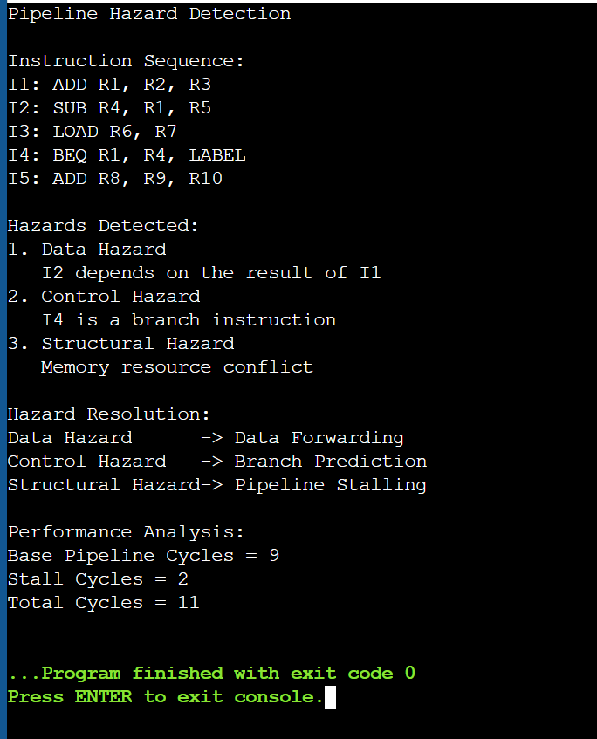
Result
Thus, data, control, and structural hazards were successfully identified and appropriate hazard resolution techniques were demonstrated.

Superscalar, Out-of-Order and SMT
Aim
To simulate superscalar, out-of-order, speculative, and simultaneous multithreading execution and analyze their effect on processor performance.
Algorithm
- Start.
- Define the total number of instructions.
- Calculate sequential execution cycles.
- Simulate superscalar execution with two instructions per cycle.
- Simulate out-of-order execution.
- Simulate SMT using two threads.
- Calculate speedup.
- Compare the execution methods.
- Stop.
C Program
#include <stdio.h>
int main()
{
int instructions = 8;
int sequentialCycles;
int superscalarCycles;
int outOfOrderCycles;
int smtCycles;
float superscalarSpeedup;
float oooSpeedup;
float smtSpeedup;
sequentialCycles = instructions;
/* Two instructions executed per cycle */
superscalarCycles = (instructions + 1) / 2;
/* Independent instructions executed out-of-order */
outOfOrderCycles = 4;
/* Two threads executed simultaneously */
smtCycles = 4;
superscalarSpeedup =
(float)sequentialCycles / superscalarCycles;

oooSpeedup =
(float)sequentialCycles / outOfOrderCycles;
smtSpeedup =
(float)sequentialCycles / smtCycles;
printf("Superscalar and Parallel Execution\n\n");
printf("Total Instructions = %d\n", instructions);
printf("\nExecution Results:\n");
printf("Sequential Execution = %d cycles\n",
sequentialCycles);
printf("Superscalar Execution = %d cycles\n",
superscalarCycles);
printf("Out-of-Order Execution = %d cycles\n",
outOfOrderCycles);
printf("SMT Execution = %d cycles\n",
smtCycles)
printf("\nSpeedup:\n");
printf("Superscalar Speedup = %.2f\n",
superscalarSpeedup);
printf("Out-of-Order Speedup = %.2f\n",
oooSpeedup);
printf("SMT Speedup = %.2f\n",
smtSpeedup);
return 0;
}

Output
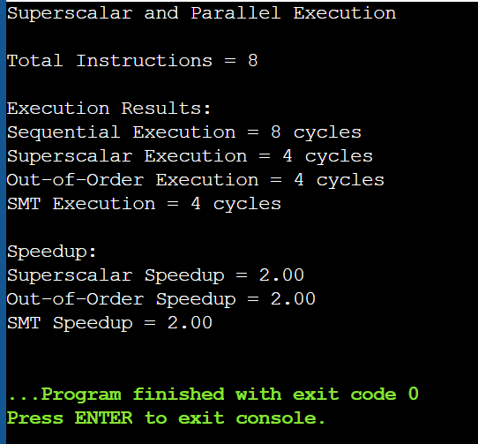
Result
Thus, superscalar, out-of-order, and SMT execution were successfully simulated. Parallel execution reduced the number of cycles and improved instruction throughput and processor performance.

